Application Solicitation
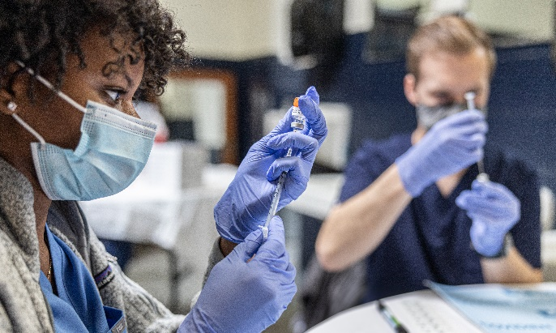
The UNC School of Medicine Caregivers at Carolina program, funded by the Doris Duke Charitable Foundation (“DDCF”), is accepting applications from physician scientists whose research productivity is impacted by family caregiving responsibilities.
If selected, faculty could receive $30 - $50k to provide direct research support (e.g., technician time, grant writing support, etc.) or buy out of clinical time so that the scientist may maintain research productivity during a transient period when caregiving demands are high. The program will also provide access to mentoring and resources. Applications are now being accepted and are due to Tania_Frost@med.unc.edu by11:59pm EST on Friday, December 16, 2022.
An Email of Intent is requested as soon as possible but is not binding. Send email of your intent to apply, including your department affiliation and general area of research directly to tania_frost@med.unc.edu. This will help in identifying appropriate reviewers.
Eligibility Criteria:
- Physician Scientist (MD, DO, or equivalent degree) at the Instructor or Assistant Professor rank with full time appointment in the UNC School of Medicine with an active U.S. Medical License. Associate Professors in their first year of appointment are eligible.
- PI on funded research or career development award that involves clinical research.
  - Clinical research is defined as the scientific investigation of the etiology, prevention, diagnosis, or treatment of human disease using human subjects, human populations, or materials of human origin if they can be linked to a patient.
- Demonstrate a compelling, time-sensitive need for supplement to that is related to family caregiving demands.
- Have 40% or more effort allocation to research at the time of application.
- Willingness to complete required questionnaires on demographics job satisfaction, sense of belonging, and other predictors of retention. These de-identified data as well as information on promotion and retention will be shared with the DDCF.

Application Materials to be compiled into one pdf file:
Two-page (maximum) description of the candidate’s background, research training, current research and funding, planned research, and career goals.
- UNC SOM-formatted Curriculum vitae. Get the latest copy of this template here.
- One page (maximum) statement of need with specific detail on the nature and extent of caregiving (e.g., type of care, how much) and examples of how caregiving responsibilities have impacted the candidate’s research productivity.
- One page proposal on how the funds would be used, with a budget, and career development milestone that would be achieved with the funds (e.g., grant submitted, research results published).
- Sources of salary support must be clearly stated in either the applicant’s CV or in the application.
In addition, in a separate document sent directly from the candidate’s chair or designee (i.e. division chief), the application must include:
- Letter of support defining the institutional commitment to the applicant, guarantee of protected research time (current and proposed); specific details regarding hours/week for non-research activities; and significance of candidate’s research and future research potential.
Review Process and Criteria:
Applications will be reviewed by an independent committee and evaluated for:
- Research training, productivity and evidence that the candidate is on a clear trajectory to an independent research career
- Need/justification related to caregiving
- Public health significance of the candidate’s clinical research project
- Support of the department chair/division chief, including statement of protected research time
- Detailed plan for the funds, including budget.
Please direct any questions to the Program Directors: Amelia_Drake@med.unc.edu or Susan_Girdler@med.unc.edu

